

American International University-Bangladesh (AIUB)  
**Department of Computer Science  
Faculty of Science &Technology (FST)  
Spring 22 23**

**<COOK LAGBE!>**

Software Requirement Engineering

Sec: **A**

Project Submitted

By

*Md. Safin (19-41298-3)*

*Nazia Hassan (19-41259-3)*

**Checked By Industry Personnel**

Name: Gazi Sani Isnine

Designation: Senior Consultant

Company: PricewaterhouseCoopers (PwC)

Sign:

Date: May 1, 2023

1. **PROBLEM DOMAIN**
   1. **Background to the Problem**

* Cooking is a fundamental part of daily life around the globe, as it is throughout most of South Asia. Bachelors or women often find themselves in charge of making food for their families and themselves. However, not everyone has the time or the ability to make meals for themselves, and many people depend on others for help. Bachelors and families could have difficulty locating a reliable and reasonably priced supply of home-cooked meals. The “COOK” is a lady who cooks and is skilled in preparing meals for bachelors and families to have notorious and delicious cuisine. Finding and hiring a “COOK” can be difficult, particularly for an individual who is unfamiliar with the area or does not have personal links to a reliable " COOK ". It's a barrier to bachelors and families from having access to home-cooked meals, which may lead to frustration and sorrow.
* The lack of a reliable and accessible platform for connecting bachelors and families with qualified and reliable “COOK” is the fundamental cause of the problem. Many bachelors and families struggle to find a “COOK” through personal connections, referrals, or social media platform groups also must rely on trial and error to find a good match. It can result in dissatisfaction and a waste of time and money. Additionally, the demand for "Cook’s" is high, but the supply is limited, which exacerbates. It affects the daily lives of many people not only, in Dhaka but throughout Bangladesh. It also highlights the issue of poverty and the challenges faced by low-income families in accessing basic services. Furthermore, the project can contribute to social and economic changes.

**1.2 Solution to the Problem**

* Creating an internet platform or app for finding a “COOK”. Users will be able to search for and hire a “COOK” depending on their preferences, such as location, cuisine type, pricing, and availability. It will give a dependable and simple method for bachelors and families to locate competent and trustworthy “COOK” The solution is especially relevant since it targets the core cause of the problem, which is a lack of a dependable and accessible platform for connecting bachelors and families with competent and trustworthy “COOK”. The approach is possible because it can achieve the corporate goals of providing a long-term solution.
* By providing “COOK” with training and certification, they can improve their abilities and learn about safe and hygienic food-making procedures. It will also contribute to the establishment of a standard of quality and professionalism among “COOK” and boost their employability. Also, it will help bachelors and families to hire a “COOK” based on their ratings and location. The solution is appropriate since it tackles the root cause of the problem by enhancing the quality of “COOK” services. However, the solution may necessitate additional time to implement.
* Currently, there are some online platforms and apps available in Bangladesh that offer services, such as Cookups, Foodpeon, Foodpanda and HungryNaki. However, these platforms mainly focus on connecting customers with restaurants and home cook foods rather than connecting them.

with a dedicated “COOK”. Therefore, there is still a huge gap in the market for a specialized platform for hiring “COOK”.

1. **SOLUTION DESCRIPTION**

**2.1 System Features** Functional requirements:

1. The system must provide a registration functionality for “USER” to create an account and log   
   into the system.
2. The system must provide a search and filtering functionality for “USER” to find a “COOK”   
   based on location, cuisine type, availability of time, ratings, and salary.
3. The system must provide functionality for “USER” to view the profiles of “COOK” and see   
   reviews/ratings from previous customers.
4. The system must provide functionality for “USER” to send a hire request to a “COOK”.
5. The system must provide a feedback and rating system for “USER” to rate their experience   
   with the “COOK”.
6. The system must provide functionality for the “USER” to make payment to the hired “COOK”.
7. The system must provide a registration functionality for “COOK” to create an account and log   
   into the system.
8. The system must provide functionality for “COOK” to accept or reject the hiring request from   
   a “USER”.
9. The system must provide a logout functionality for “USER” to securely log out of the system.
10. The system must provide a logout functionality for “COOK” to securely log out of the system.

Quality attributes:

1. Reliability: The system should be reliable, and customers should be able to depend on it to find a trustworthy and competent “COOK”.
2. User-friendly: The system should be easy to use and navigate for both customers and “COOK”.
3. Secure: The system should ensure the privacy and security of customer and “COOK” information and transactions data.
4. Scalability: The system should be scalable to accommodate a growing number of “USERS” and “COOK”.
5. Performance: The system should perform efficiently and quickly, without any delays or errors.
6. Maintainability: The system should be easy to maintain and update to fix any issues or add new features.

**2.3 UML Diagrams (Use Case Diagram, Class Diagram, E-R Diagram)**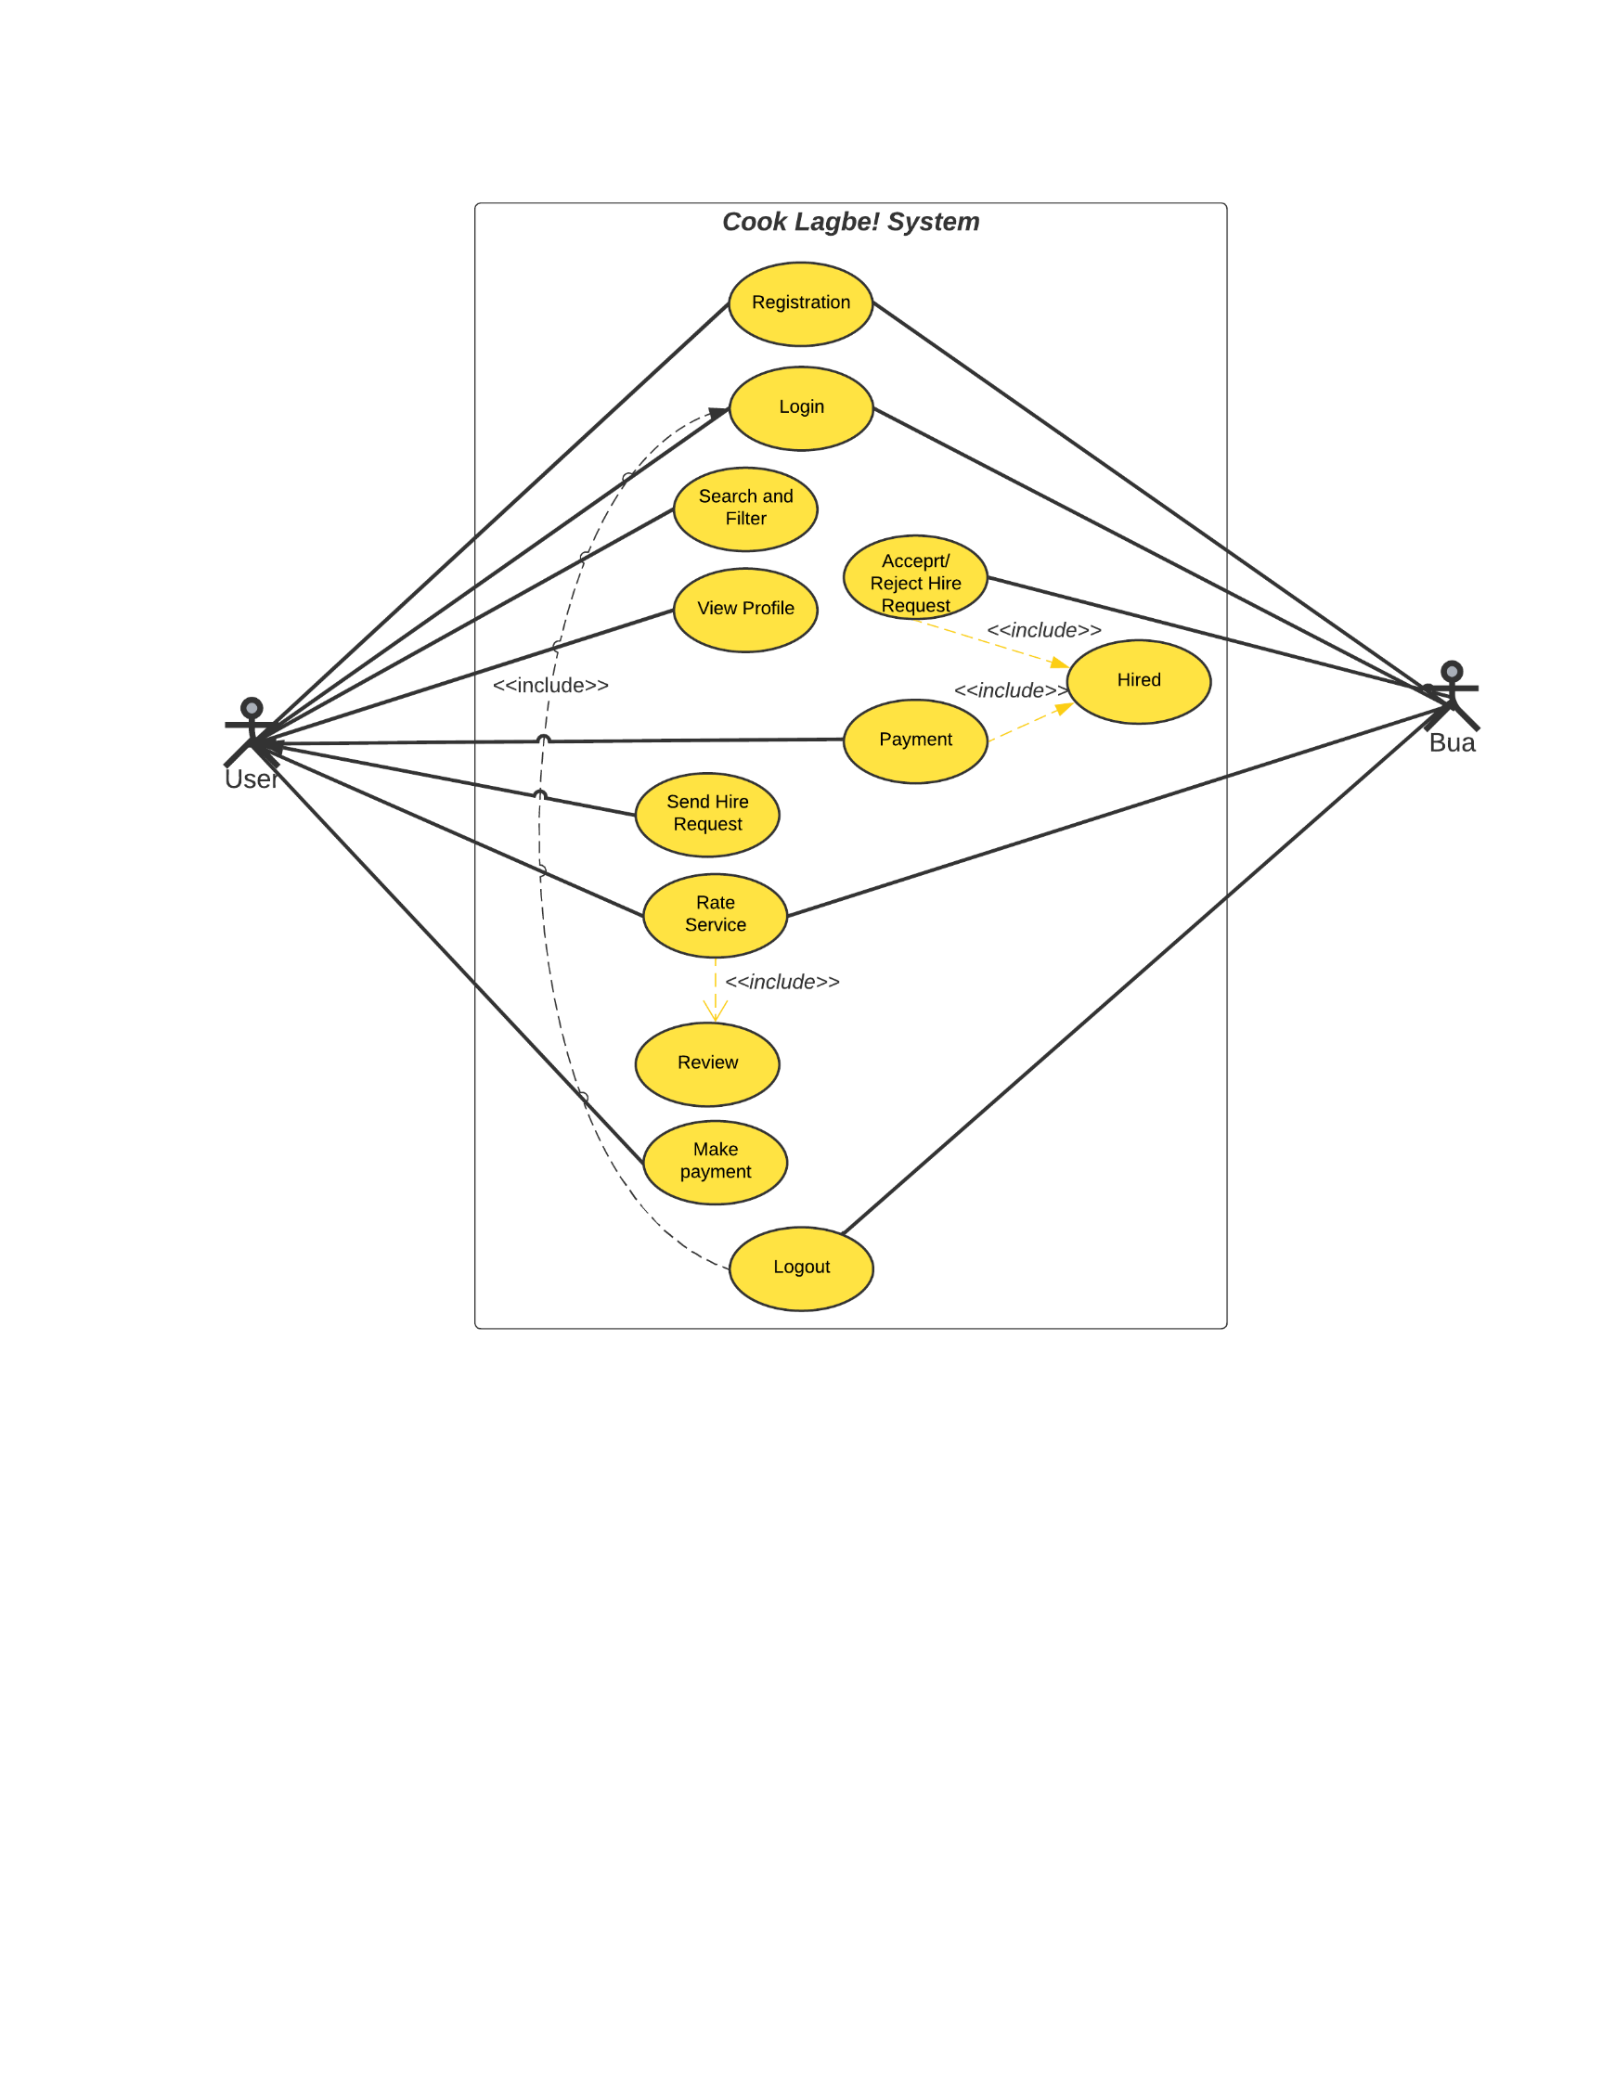  
   
  
  
  
  
  
  
  
  
  
  
  
  
  
  
  
  
 Diagram 1: Use Case Diagram

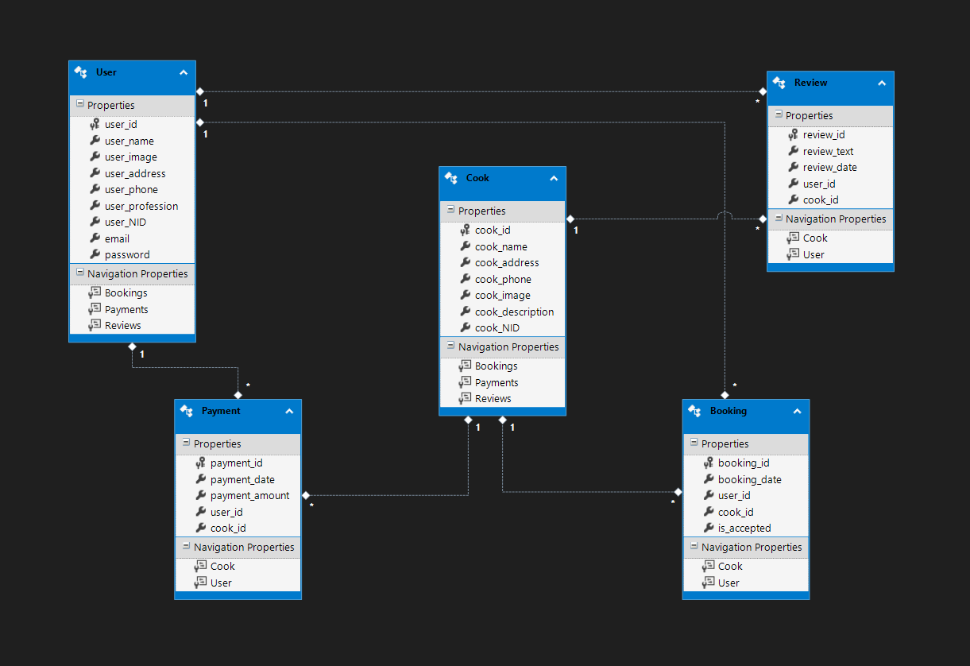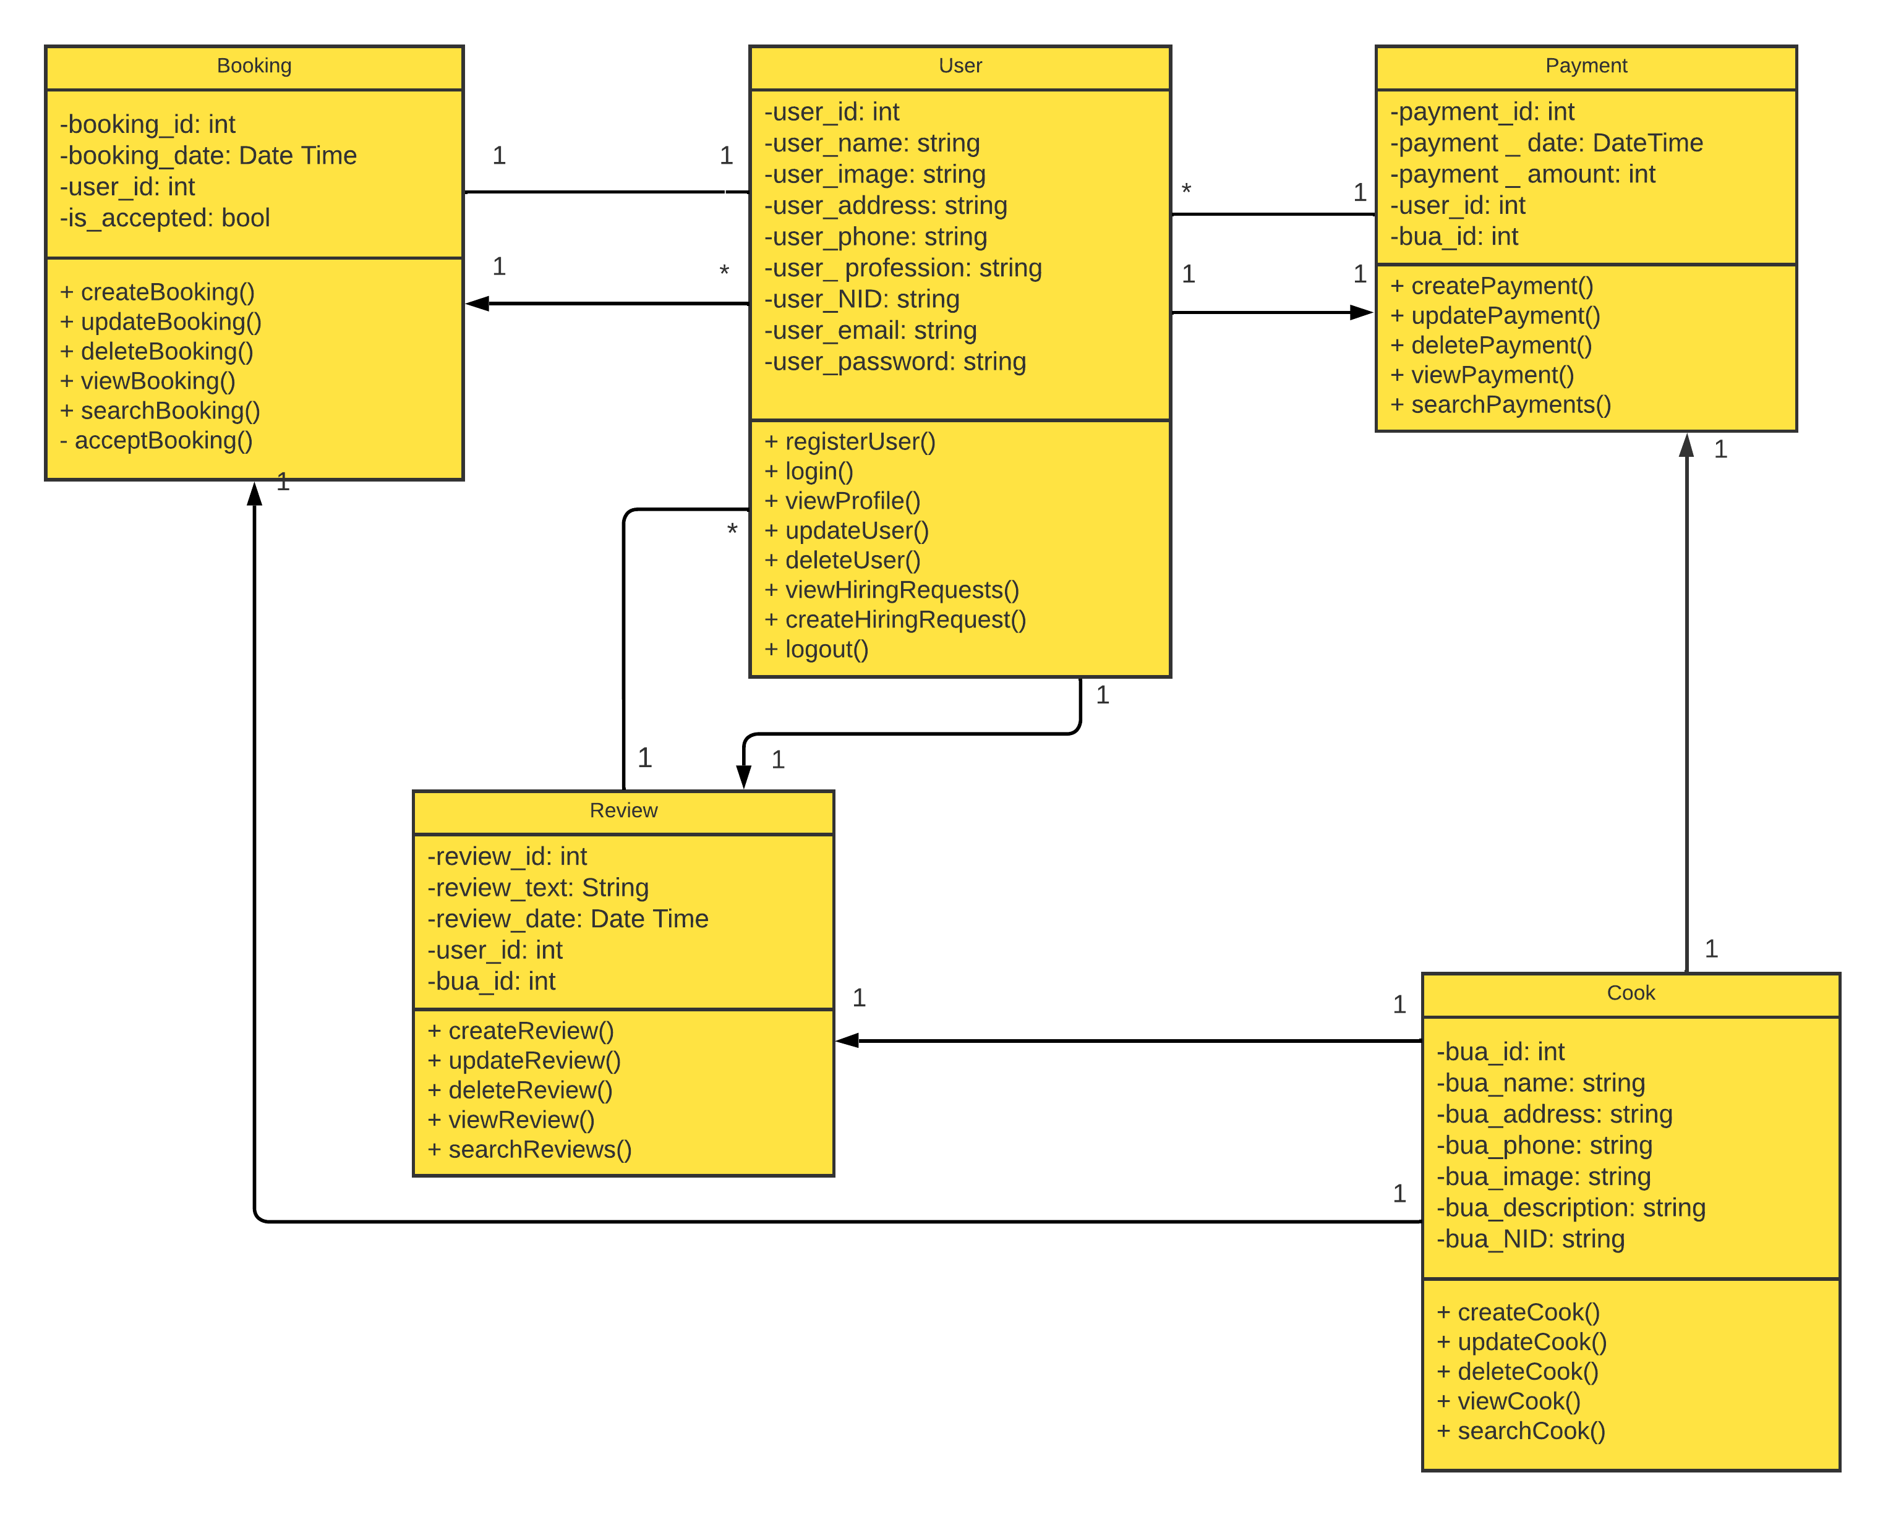  
Diagram 2: Class Diagram  
  
  
  
Diagram 3: E-R Diagram

**2.2 System UI**

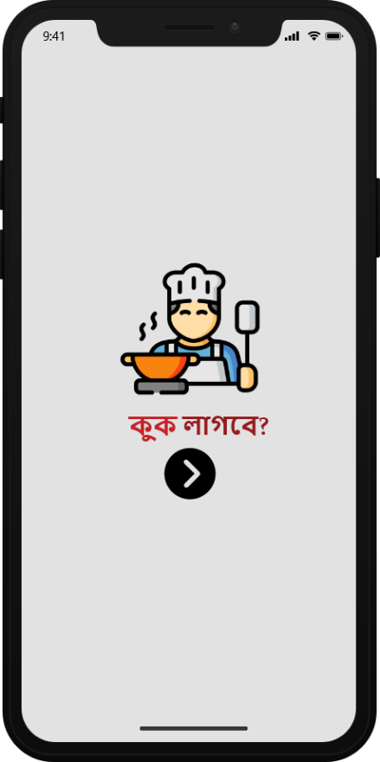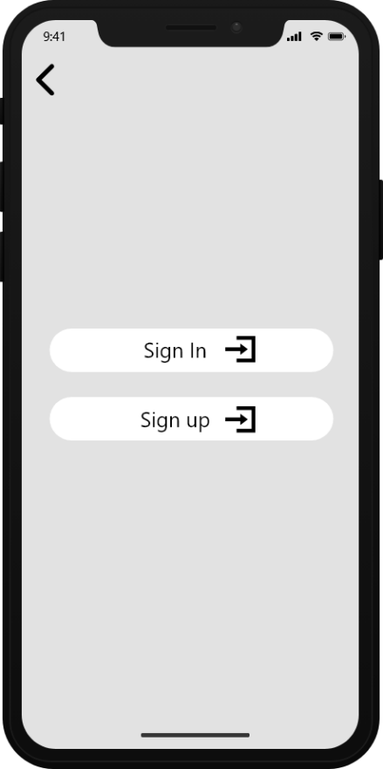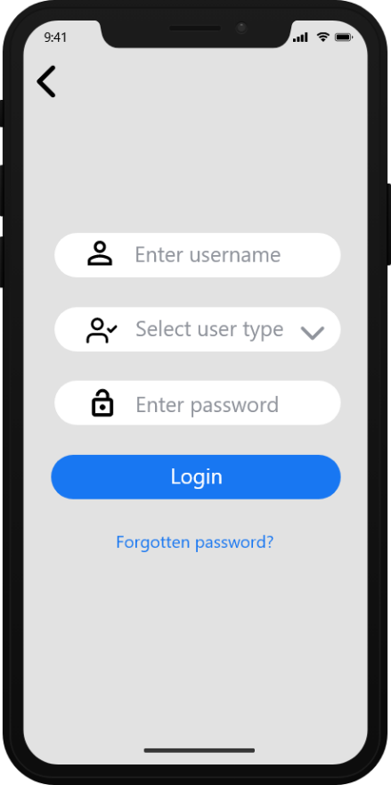

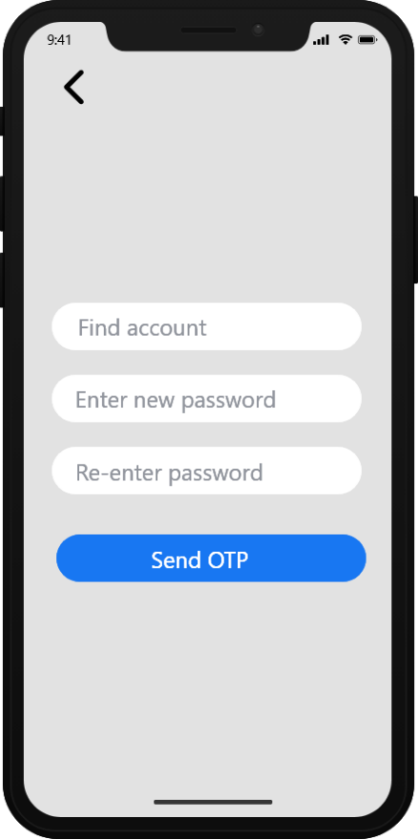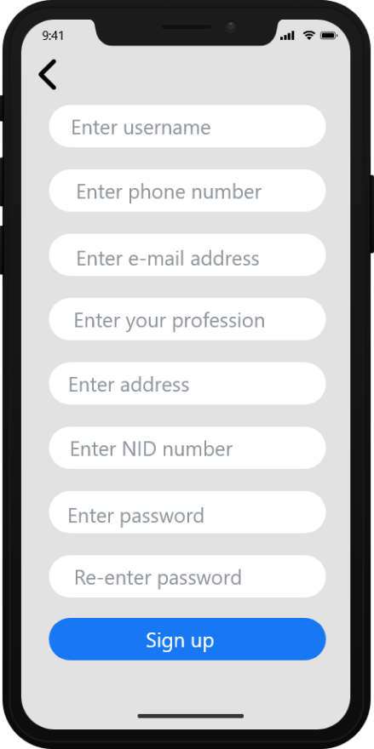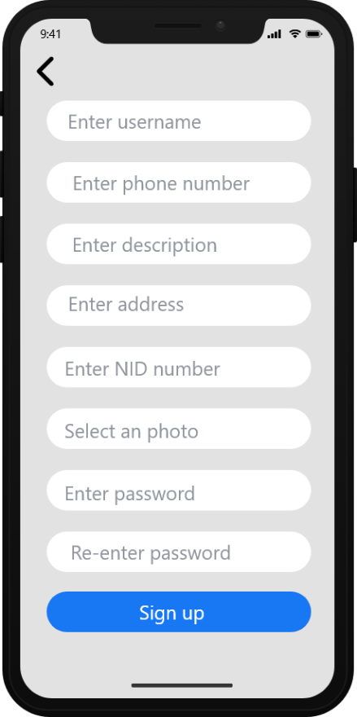  
  
  
  
  
  
  
  
Figure 1.1 : App Launch Screen Figure 1.2 : Sign-in & Sign-up Screen Figure: 1.3 : Login Screen

Figure 1.4 : Cook’s Create Figure 1.5 : User’s Create Figure: 1.6 : Password Account Screen Account Screen Change Screen

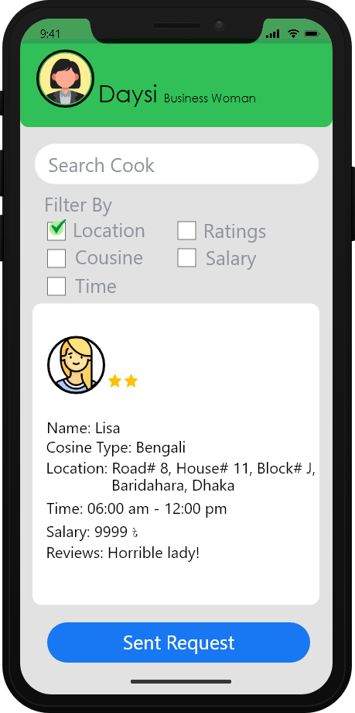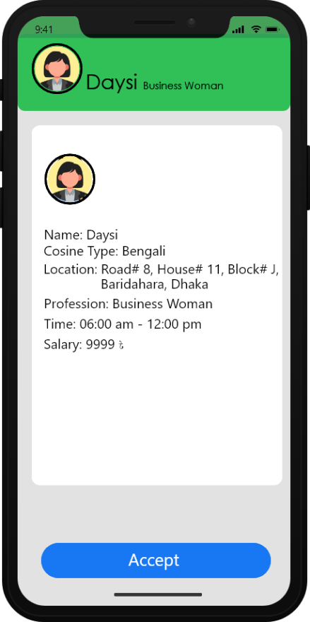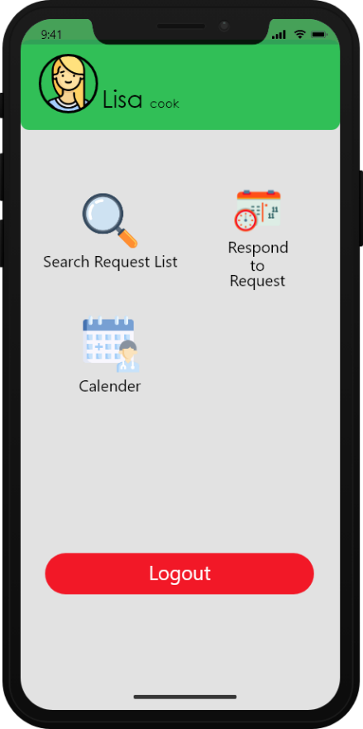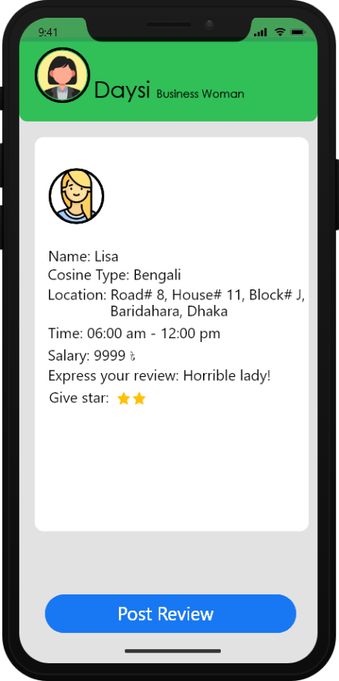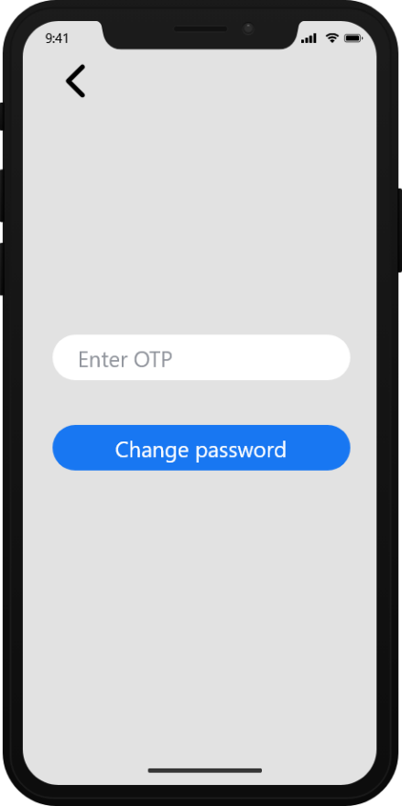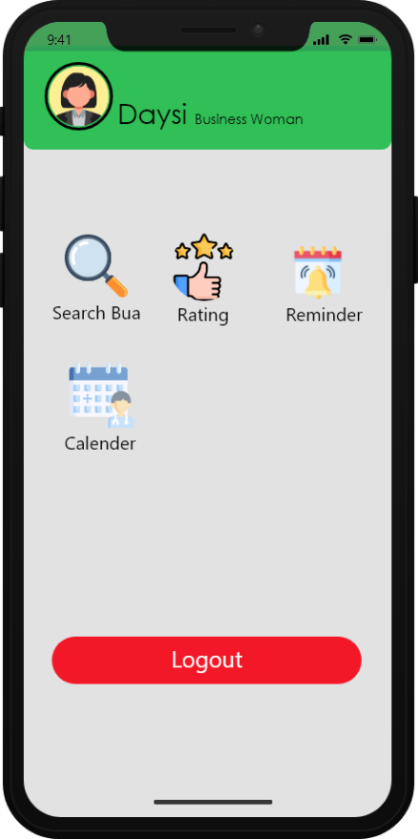  
  
  
  
Figure 1.7: Change Password Figure 1.8 : User Screen After Log-in Figure 1.9 : Search Cook

Figure 2.1: Cook Profile Figure 2.2 : Request Accept Figure 2.3 : Review

1. **Social Impact**

The project idea of developing an app for finding a “COOK” can provide various benefits to society. The app will make the process easier for bachelors and families to hire skilled and trustworthy “COOK” to create home-cooked meals. While also contributing to the local economy by creating jobs for domestic employees. The platform can help “COOK” to improve their abilities and understanding of safe and sanitary food-making operations by providing them with training and certification. The initiative can contribute to social and economic transformation by addressing the issue of poverty and the barriers that low-income households encounter in obtaining essential services. It can empower women by giving them job options and helping their financial independence. The app would allow consumers to find and hire a “COOK” online, saving them time and effort. Overall, the project concept can help society by solving a fundamental problem many bachelors and families experience.

1. **Development Plan with Project Schedule**  
   01. Planning Phase

* Identified project scope, objectives, and requirements.
* Created project plan, schedule, and budget.
* Defined roles and responsibilities of team members.
* Determined risks and mitigation strategies.
* Established communication channels with stakeholders.

02. Analysis Phase

* Gathered and documented requirements.
* Conducted feasibility study and cost-benefit analysis.
* Defined system architecture and design.
* Created user interface design and user experience.

03. Design Phase

* Developed detailed design specifications.
* Created high-level and low-level design.
* Created data model and database design.
* Identified and evaluated third-party software components.

04. Development Phase:

* Wrote and tested code.
* Conducted unit testing and integration testing.
* Created system documentation.
* Created user documentation.
* Implemented configuration management and version control.

05. Testing Phase

* Conducted system testing and user acceptance testing.
* Created and executed test cases.
* Identified and tracked defects and issues.
* Conducted performance testing.

06. Implementation Phase

* Prepared for deployment.
* Created user training materials.
* Planned and executed data migration.
* Installed and configured software.
* Conducted post-deployment testing.

07. Maintenance Phase

* Provided ongoing support.
* Conducted maintenance and bug fixes.
* Implemented new features and enhancements.
* Managed change requests.
* Monitored performance and security.

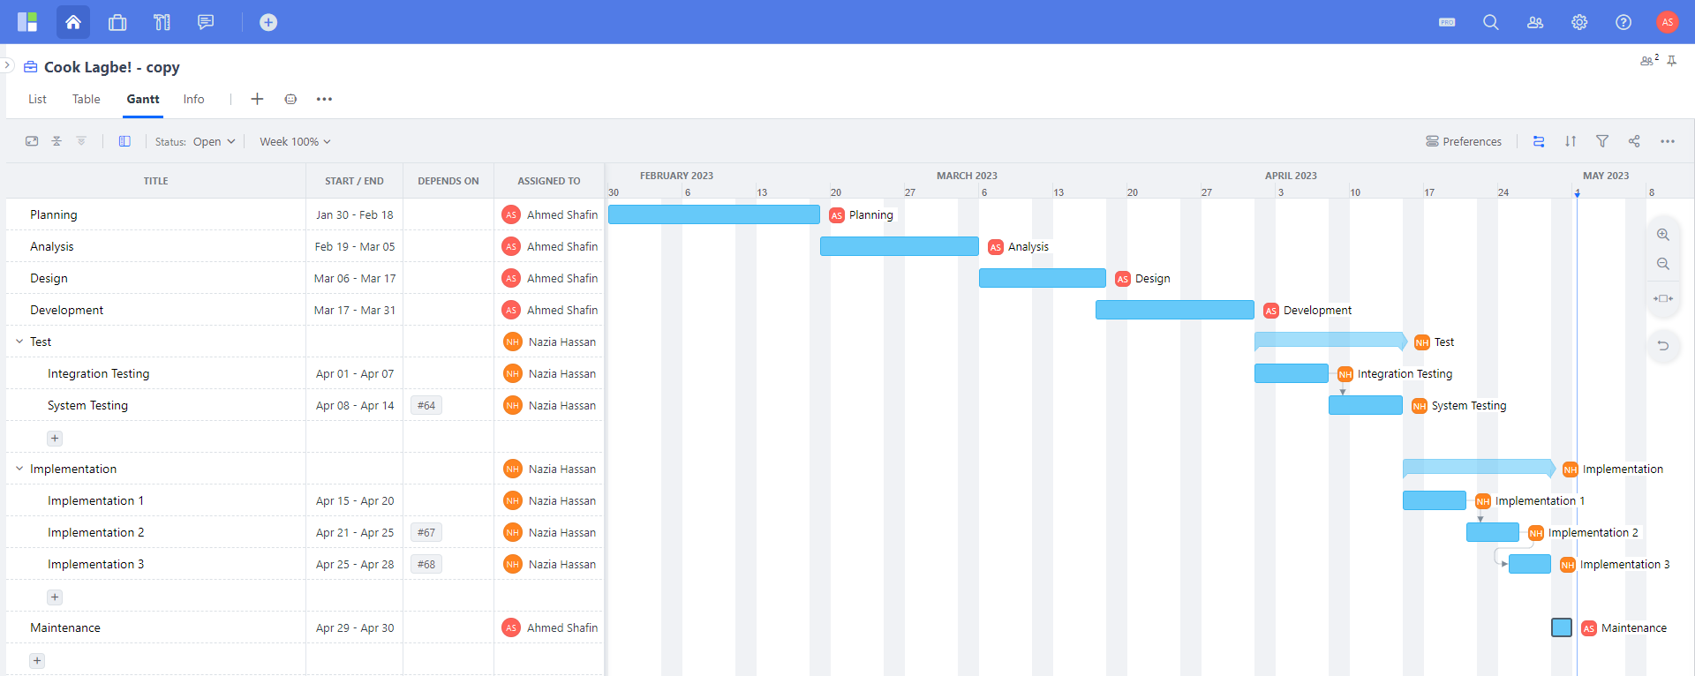

1. **Marketing Plan**

The short-term marketing strategy can concentrate on raising awareness of the app and its advantages among the bachelors and families through social media campaigns, posters, leaflets, and local advertising. It can help to stimulate interest among potential users and create an aura.

The long-term marketing strategy can focus on expanding awareness of the app and building a loyal client base. Strategic connections with local businesses and organizations, involvement in relevant events, and referral programs that motivate existing users to refer their friends and family to the platform can help achieve this.

Overall, a well-crafted marketing plan can help to make the project idea of creating the app for hiring a “COOK” successful and popular among the community.

1. **Cost and Profit Analysis**

* Constructive Cost Model:

Software Project Type: Organic

Coefficient<Effort Factor> = 2.4

So, P = 1.05 and T = 0.38

SLOC = 1000 Lines

Persons-months, PM = Coefficient * (SLOC/1000) ^P

= 2.4 * (1000 /1000) ^1.05

= 2.4

Development time, DM = 2.50 * (PM)^T

= 2.50 * (2.4) ^0.38

= 3.48

= 3.5 months

= 457 Working hours in total (Per week 30 hours)

Required number of total people, ST = PM/DM

= 3.50/2.4

= 1.45

= 2 people

* Total Budget:

Developer/Tester salary of 3.5 months:

Per employee salary per month = 30,000 Taka = 250 Taka per hour

Total salary = 250 * 457 = 114,250 Taka

Requirement analysis:

Required time = 3.5 month = 22 working days = 77 working hour

Requirement analysis persons per hour salary = 150 Taka

Total requirement analysis salary = 150 * 77 = 11,550 Taka

Transportation cost:

10,000 Taka (Approximate)

Hardware expense:

1,50,000 Taka (Approximate)

Rent expenses:

Room per month = 15,000 Taka

Total in 3.5 months = 3.5 * 15,000 Taka = 52,500 Taka

Project manager’s salary of 3.5 months:

Per month salary = 33,000 Taka

Total salary = 33,000 * 3.5 = 1,83,750 Taka

Total expense: 114,250 + 11,550 + 10,000 + 1,50,000 + 52,500 + 1,83,750 = 5,22,050 Taka

Profit: 30% of total expense = 5,22,050 * 30% = 1,56,615 Taka

Total budget: 5,22,050 + 1,56,615= 6,78,665 Taka

1. **Reference**

* [Cookzy - Hire Cooks and Chefs – Apps on Google Play](https://play.google.com/store/apps/details?id=in.cookzy.app&hl=en_IN)
* [Zen - Cook Finder - Cooks, chefs and and catering service providers. All in one place! (zencookfinder.com)](https://zencookfinder.com/)